“FileFolderAccess” Analysis
Check the files in this folder and answer the following questions:

      - LECmd Output.csv: Was there any user interaction on this machine with an optical disk drive? If yes, when did that happen? (exact timestamp; e.g. 17/02/2021 17:02:34 TIMEZONE)

Yes, there has been such interaction.
6/3/2002 11:58:35 PM EST
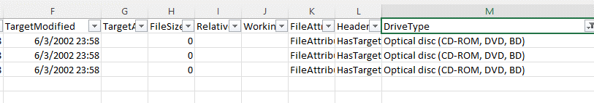

      - LECmd Output.csv: Was there any user interaction on this machine that shows that an index.htm file was stored in a removable storage media? If yes, which day the interaction happened? (e.g. 17/02/2021 TIMEZONE)

Yes, there has been such interaction.
The day that interaction happened was 6/3/2002 EST
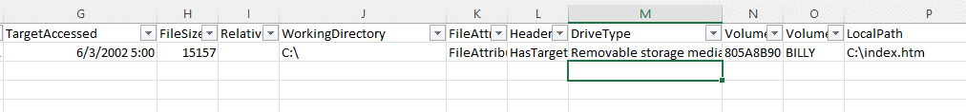

      - LECmd Output.csv: Was there any user interaction on this machine that shows access to a folder created by an Online Service? When this happened? (exact timestamp(s), e.g. 17/02/2021 17:02:34 TIME- ZONE )

There has been interaction.
Timestamps of access are:
5/14/2002 5:12:59 PM EST
6/5/2002 12:14:29 AM EST
6/5/2002 12:24:33 AM EST
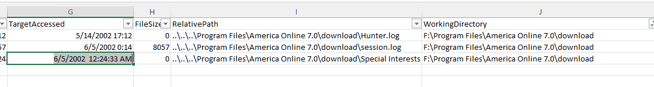

      - LECmd Output.csv: Was there any user interaction that shows a zip file was stored in a folder? If yes, which folder? When this particular folder was last accessed? (exact timestamp; e.g. 17/02/2021 17:02:34 TIMEZONE)

Yes, there has been an interaction where a zip file has been stored to
F:\Hunter Pics\103-0356_IMG.zip
Last accessed at: 6/3/2002 9:17:32 PM EST

“ProgramExecution” Analysis
Check the files in this folder and answer the following questions:

      - PECmd Output.csv: When Internet Explorer was last run? (exact timestamp; e.g. 17/02/2021 17:02:34 TIMEZONE)

Internet Explorer (IEXPLORE.exe) was last run at:
6/4/2002 11:40:28 PM
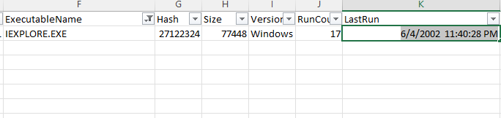

      - PECmd Output.csv: What was the name of last executable file that was run on this computer? What is this file related with?
The last executable file run was:
IMAPI.EXE at 6/5/2002 12:40:02 AM EST
The file is associated with Discs management, like burning, loading and more.
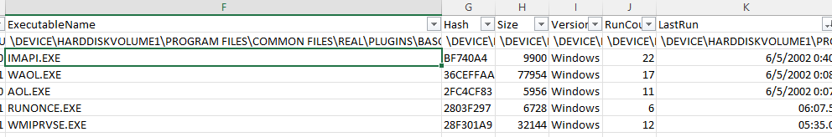
      - PECmd Output.csv: Which 2 programs that were used in the last 3 days were mostly run in this system?

IMAPI.EXE(22) and RUNDLL32.EXE(20) have been the most run applications. But excusing, RUNDLL32.EXE as system program, it has been WAOL.EXE(17).

      - PECmd Output.csv: Did this user attempt to access his/her emails in these last three days? If yes, when did this happen? (exact timestamp; e.g. 17/02/2021 17:02:34 TIMEZONE)

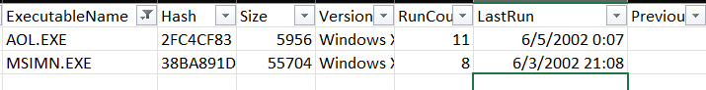
AOL on 6/5/2002 12:07:59 AM and MSIMN on 6/3/2002 9:08:20 PM

